Zentangles: A Guided Meditation
  - AMI-EAA Virtual Summer Conference 2021
  - Presenter: Christina Carroll

The Zentangle method of drawing is an easy-to-learn, relaxing, and fun way to create beautiful images by drawing structured patterns. It increases focus and creativity, providing both artistic satisfaction and a sense of personal well-being. These workshops will provide a background in the Zentangle method's history, introduce the basic steps, and explore the associated vocabulary and tools. Attendees will be immersed in creating Zentangle art and receive guidance on developing a personal practice and giving presentations in the classroom.

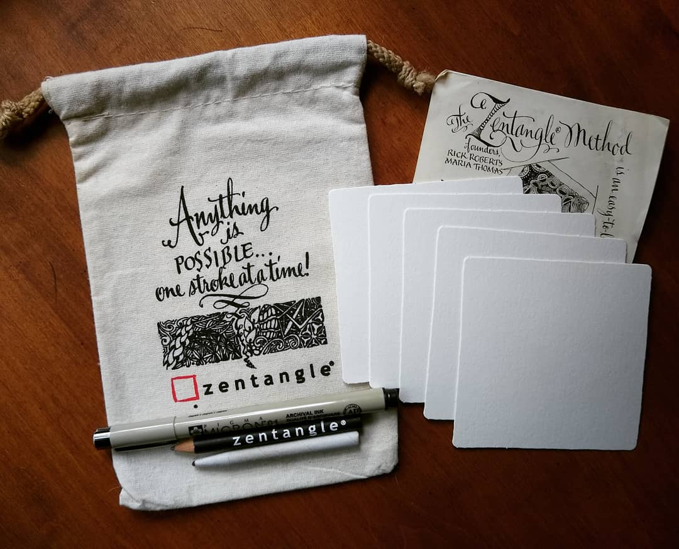 | 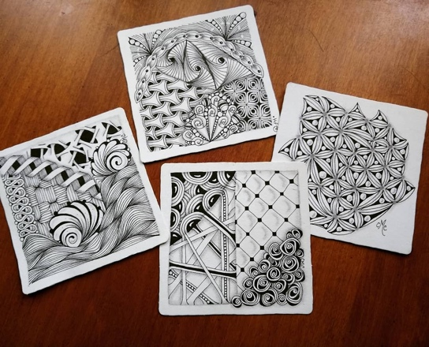
Figure 1. Zentangle Supplies | Figure 2. Finished Zentangle Tiles

Materials:
Black Pigma Micron 01 pen
Graphite pencil
Tortillon
2+ White Zentangle tiles – 3 ½ inch square

Note: These materials can be found at Zentangle.com, Amazon, and Blick art. The Pigma Micron pen, graphite pencil, and tortillon can usually be found at Michaels or Hobby Lobby. Every once in a while I’ll see Zentangle tiles at these craft stores, so check your local store and see if you have any luck. I recommend trying to get these specific materials, especially if it’s your first time trying out Zentangles. However, if you have comparable materials, especially if you’re an experienced tangler, feel free to use what you have!

Further Thoughts on Zentangle Supplies
Markers and Pens
Pigma Micron 01 is the pen of choice in the Zentangle community. However, some prefer the Pigma Micron PN, Copic Multiliner SP, or any black ink pen with a fine tip. For the classroom, I prefer using Sharpie Ultra Fine Point markers (Figure 3). The tips are less likely to get damaged due to excess pressure and the children enjoy the rich colors. However, Sharpie ink bleeds into the paper and spreads. Thus, you cannot achieve the fine detail as you would with the other pens listed and you will likely want to use larger, thicker paper. Finally, I love using Gelly Roll pens, especially on tan, gray, black, and painted paper. While my white and gold pens get the most use (Figure 4), Moonlight pens work wonderfully on black paper (Figure 5) and Stardust pens add a touch of glitter.

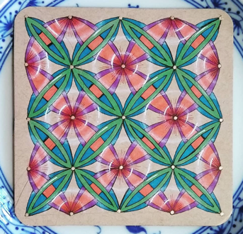 | 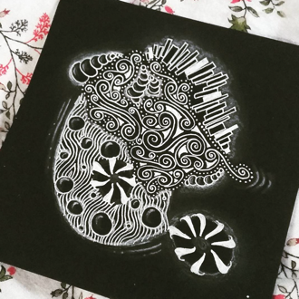 | 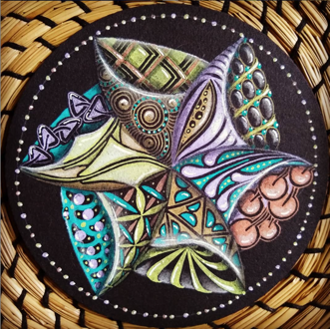
Figure 3 | Figure 4 | Figure 5

Paper and more!
Official Zentangle tiles are lovely for personal practice. The paper is such high quality that it feels like a real treat to work with. They come in white, tan, gray, and black. Official tiles also take watercolor well (Figure 6). If I’m not using an official tile, I like to use Bristol paper, cutting it to whatever shape or size I want for my project. It too can be found in white, tan, gray, or black. For the classroom, I often cut posterboard paper into 4 ½ inch squares. However, you can truly tangle on just about any surface given the right art supplies! I tangle in notebooks, on my journal, and on envelopes (Figure 7). I tangle over watercolor backgrounds. I even tangled my laptop pouch (Figurer 8)!

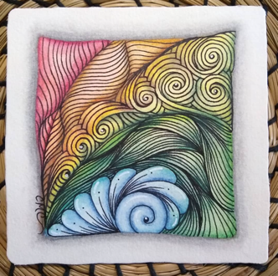 | 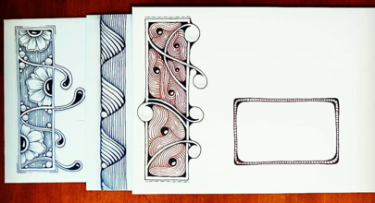 | 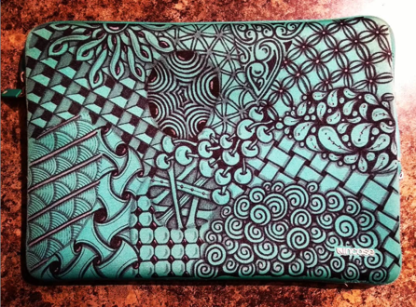
Figure 6 | Figure 7 | Figure 8

Resources
There’s a plethora of Zentangle resources out there and many of them are free! Here are a few suggestions. Enjoy exploring!

Online
- Zentangle.com
- Tanglepatterns.com – Here you can find a collection of different drawing patterns developed the folks at Zentangle, Inc. (official Zentangle patterns) and from artists around the world. If you develop a pattern, you can submit it to the website, too! A Mother of one of my former students has a few posted: Sand Swirl and Palrevo. I have one posted (Eau) and am about submit another (Amprus)
- YouTube – Sometimes, it’s just easier to watch someone draw and explain a pattern! Here are a few folks that I follow, along with my own channel:
  - Zentangle – My favorite videos are their project pack tutorials. They have a playlist called “For kids” where you can ideas for tangling in the classroom.
  - Zen Linea
  - Eni Oken – She also has a website where she sells e-books, offers courses, and even a monthly art club with exclusive material.
  - The Tireless Tangler – She’s best known for her annual 100 Days of Zentangle challenge.
  - Taking Time to Tangle – This is my channel. The other folks on this list earn an income from their channels. Therefore, they post videos more frequently. I just post videos for fun and don’t intend on using it as a source of income. However, I do take suggestions for future videos and plan on creating a playlist of Montessori art lessons, including Zentangles. It may take some time though… Finishing my PhD takes precedence over posting YouTube videos!
- Facebook groups – There are so many ways to connect with other tanglers on Facebook! Many groups have a specific focus, so be sure to check the group guidelines before posting your artwork. Here are some of my favorite groups:
  - Today’s Tangles
  - Today’s Tangles: Keeping it Classic – Classic Zentangle tiles are ones that only use the materials we are using in this workshop. This group specifies that you must follow the weekly prompt when posting artwork.
  - ZIA Tips, Tricks and Techniques – ZIA stands for Zentangle Inspired Artwork. This usually means that the artist is using Zentangle patterns, but may use materials and supplies other than the ones we’re using in this workshop.
Books
There are many books out there, but I have only found a few that I feel that offer more than you can find for free online.
- The Book of Zentangle by Rick Roberts and Maria Thomas
  - This book tells the story of how Rick and Maria developed the Zentangle method and explores the philosophy behind the method.
- Zentangle Primer Vol. 1 by Rick Roberts and Maria Thomas
  - This book leads you through developing a personal Zentangle drawing practice. It walks you through the creation of your first tiles and suggests ways to explore further once you feel comfortable with the method.
- A Zentangle Collection of Reticula and Fragments by Rick Roberts and Maria Thomas
  - The book offers another approach to Zentangle drawing that may be appealing to folks who enjoy geometric shapes and patterns.
- Zentangle Dingbatz: Patterns and Projects for Dynamic Tangled Ornaments and Decorations by Brian Crimmins, CZT – CZT means Certified Zentangle Teacher. This book offers inspiration for tangling projects. Crimmins explores tangling envelopes, journals, placecards, and more!

Wrapping Up
I’m excited to meet you at the AMI-EEA Summer conference! I hope this helped you get a taste for what materials you’ll need for the conference and some resources to explore. If you have any questions feel free to reach out. Here’s my contact information:

Email: cmc3jn@virginia.edu
Facebook: Christina Carroll
Instagram: ccarroll427

